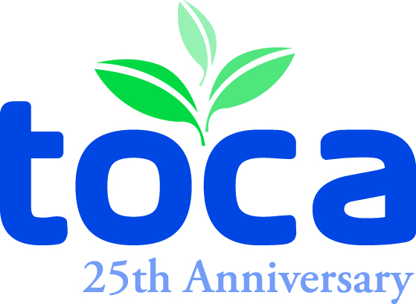

2014 MEMBERSHIP APPLICATION

TURF AND ORNAMENTAL COMMUNICATORS ASSOCIATION

THIS IS A NEW MEMBERSHIP. THIS IS A MEMBERSHIP RENEWAL.

NAME_____________________________________________________________________________________
TITLE_____________________________________________________________________________________
EMPLOYER_________________________________________TYPE OF BUSINESS_____________________
ADDRESS__________________________________________________________________________________
CITY______________________________________STATE______________ZIP CODE___________________
WORK PHONE___________________________________FAX_______________________________________
CELL ___________________________________________
EMAIL____________________________________________________________________________________
TWITTER ADDRESS (Optional) _______________________________________________________________

Please notify TOCA of any changes to your contact information during the year.

IF AGENCY, LIST CLIENT(S) FOR OUR DATA BASE __________________________________________________________________

If you are a new member, who referred you? _____________________________________________________________________________

List the percentage of professional time spent on the following communications duties:
Writing ______ Production ______ Publishing __________ Circulation ______
Editing ______ Advertising ______ Public Relations ______ Photography ______
Other _________________________________________________________________________

Annual TOCA Membership Dues
Individual - $125 Student - $25
Group - $125 (1st member) + $75 for each additional member from the same company or association.

You may pay dues: with a check made payable to the Turf and Ornamental Communicators Association.
Please return this Membership Application (by fax/email/mail) with your check.
online with a credit card (VISA/MC/AMEX) at www.toca.org under Membership Section.

● Do you know of anyone else who might be interested in joining TOCA? Is so, please list:
Name __________________________________________________________________________________
Address __________________________________________________________________________________
Phone ________________________________

● Are you interested in serving on a TOCA committee? If so, please check those committees of interest:
Membership Annual Meeting Awards Program Scholarship

● Would you like information about sponsorship opportunities? Let us know and we will contact you.
Yes No

My age is: 35 years or younger. 36 years or older. (This question is optional.)

Address all correspondence to: TOCA, 605 Columbus Ave. S., PO Box 156, New Prague, MN 56071
Attn: Den Gardner, Barb Ulschmid or Kathy Heyda. Phone: 952-758-6340 Fax: 952-758-5813
Email Address: toca@gandgcomm.com Web site: www.toca.org

