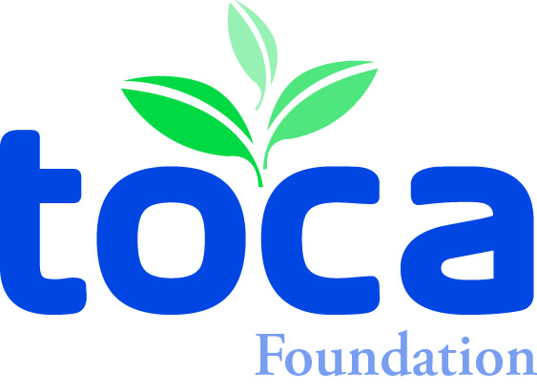

FOR IMMEDIATE RELEASE CONTACT: Den Gardner
toca@gandgcomm.com
952/758-6340

NEW PRAGUE, MINNESOTA (May 5, 2017) – The Turf & Ornamental Communicators Association (TOCA) Foundation is creating a marketing internship program, beginning in 2018.

The marketing internship program is being funded through the TOCA Foundation by Den/Sandy Gardner and Dave Hansen. The Gardners are owners of Gardner & Gardner Communications, a marketing/association management firm based in New Prague, MN. Hansen is Partner/CEO of Swanson Russell, a marketing communications firm based in Lincoln, NE.

Den, who started TOCA back in the late 1980s, has been involved in many Green Industry ventures over the years, including Project EverGreen and work with several suppliers in marketing communications. Dave has committed more than three decades to the Green Industry, representing dozens of clients through his marketing communications firm and volunteering for numerous industry organizations.

Under this new internship program, TOCA will coordinate the internship program and selection. TOCA member companies that are involved in public relations activities will host the intern. This is a five-year commitment by Hansen and the Gardners.

Some other key details include:
- Internship will be worth $5,000 -- $4,000 as a stipend and $1,000 to be used to attend and assist in the execution of the TOCA annual meeting in May 2018.
- The internship will be 8-10 weeks long and begin approximately in May 2018.
- The deadline for applying to host the intern is mid-December. The host organization will be chosen by the end of this year.
- Student applications will open Feb. 1, 2018, and the selection will be in April.
- Intern will be chosen by a representative of the host organization, along with a representative of the sponsoring parties, plus one board member and/or the chair of the TOCA Futures Committee.

Page 2

Speaking on behalf of the donors, Den Gardner said: “Dave Hansen, plus Sandy and I have spent our careers working in marketing communications in the Green Industry. This is one way for us to give back to the industry through this internship program. TOCA is the right organization to execute this program, especially with its almost 30 years of existence as the marketing communications membership organization for the Green Industry. We are excited to get this program off the ground for next year.”

This marketing communications internship program for TOCA will complement its existing publishing internship program, which has been sponsored by Bayer for many years.

For more information, go to www.toca.org. Or email/call Den Gardner or Kristy Mach at the TOCA office for more information – toca@gandgcomm.com or (952/758-6340).

The End

